**REPORT**

**ON**

**ADVANCE SOFTWARE ENGINEERING**

**TUTORIAL 6**

**NAME: DIVYA VALA**

**STUDENT ID: 16198985**

**AIM:**

To create log-in service as rest service and show the log-in service URL in separate tab.

**OUTPUT:**

Login page created in tutorial2 is used to create log-in rest service.

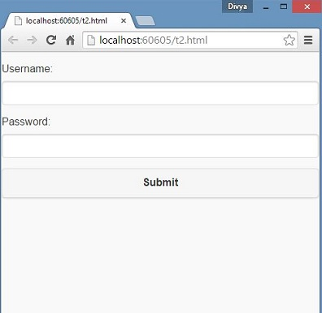

On clicking submit button Log-in service will return “WELCOME<username>”

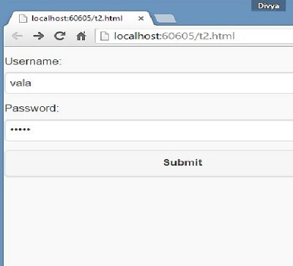

So the final output will be

